Disabled People’s Manifesto

Part 2

Manifesto: here, this means our document that sets out what we want the government to do, to push for Disabled People’s rights.
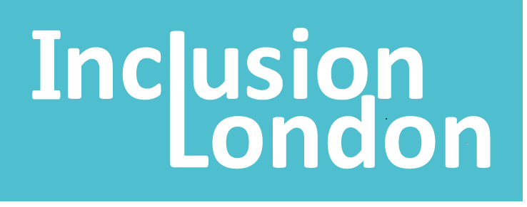 | This manifesto is by Inclusion London
Inclusion London: we are a user-led organisation based in London. We push for equality for London’s Deaf and Disabled people.
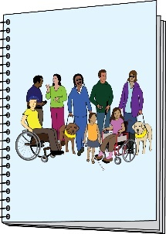  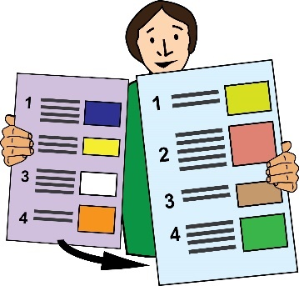 | This is Part 2 of 6 of this Manifesto.  Please make sure you read the other parts of the Manifesto.
Transformation: this means pushing for big changes

 | We want the government to accept that getting rid of barriers will cost lots of money. To get rid of barriers, austerity must end.
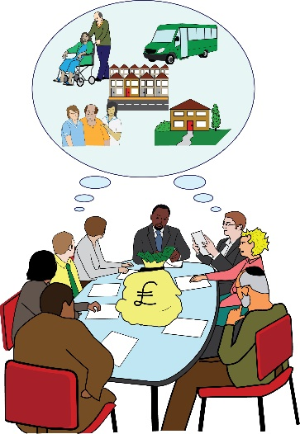 | Putting money into good public services is not a waste of money. It is not wasting the budget.  In fact, it is an investment in everyone’s quality of life.
Budget: here, this means the government’s plan about the money they have and how they will spend it.

Invest or investment: this means using time, money and other resources to make long-term change.
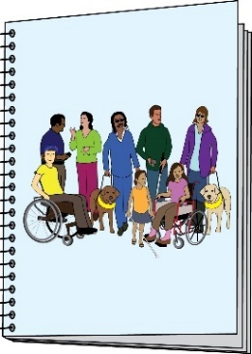 | We need a long-term Disability Strategy. This should be co-produced with Disabled people and our organisations.
Strategy: this means a long-term plan.

Co-produce or co-production: here, this means the government working together with Disabled people.
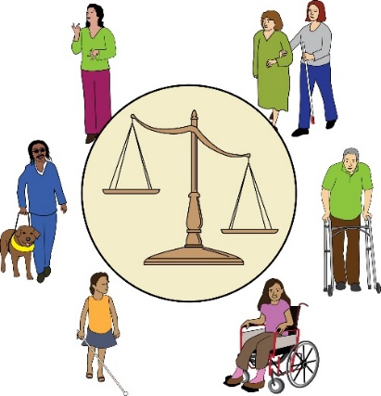 | This strategy should deal with the structures in society that are causing our oppression. The strategy should lead to change and investment.
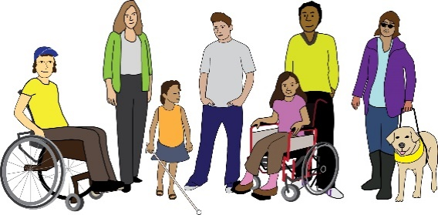 | This is so that Disabled people can have really good lives.  This means Disabled people of all ages, genders and backgrounds.

