Disabled People’s Manifesto

Part 3

Manifesto: here, this means our document that sets out what we want the government to do, to push for Disabled People’s rights.
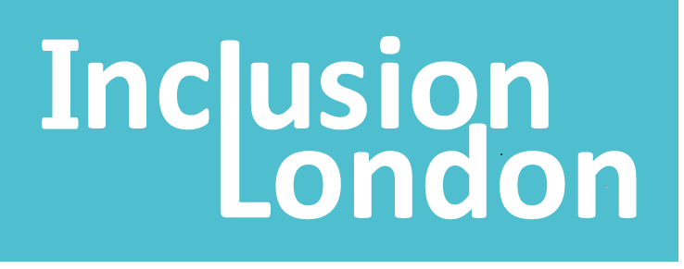 | This manifesto is by Inclusion London
Inclusion London: we are a user-led organisation based in London. We push for equality for London’s Deaf and Disabled people.
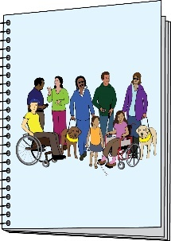  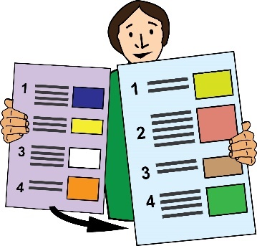 | This is Part 3 of 6 of this Manifesto.  Please make sure you go to the other parts of the Manifesto.  .
Four Step Plan – Step 2

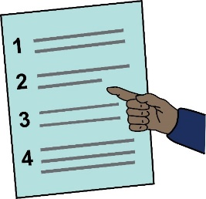 | Representing Disabled people and having a voice
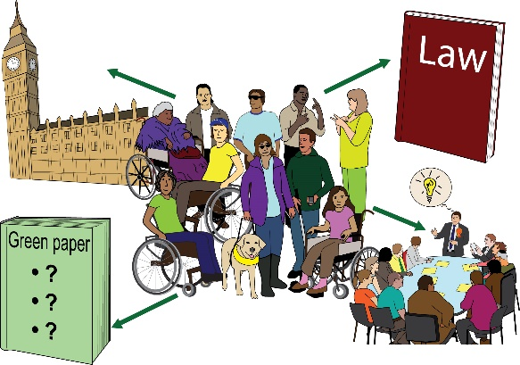  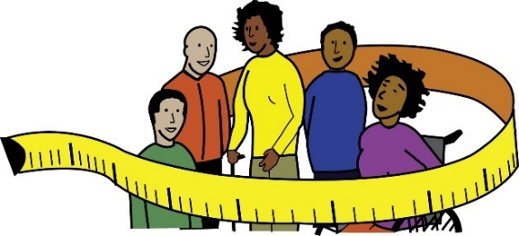 | We want Disabled people to take part across all political and public roles.  We need adjustments to be put in place. We need this to happen for all the adjustments that are needed.  This is so we can reach real justice and equality.
Adjustments: here, this means making changes to get rid of barriers for Disabled people.
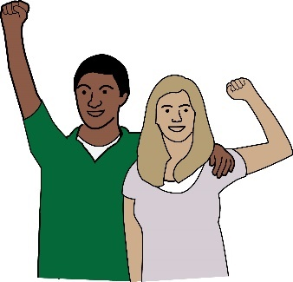 |  | Disabled People’s Organisations are responsible for our community.  These organisations must be seen as the most important advocates for us.
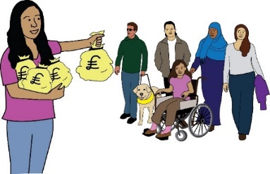 |  | They must be given the funding needed to carry out their important work.
Advocate: here, this means people and groups who stand up for and talk about Disabled people’s rights
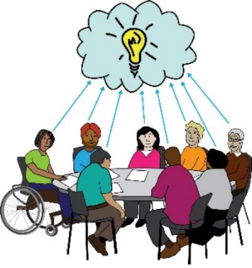  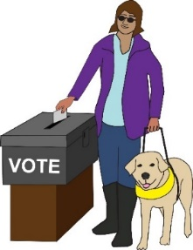 |  | Disabled People’s Organisations must take part in making decisions. This must be in local settings and across the UK.  All Disabled people must be able to fully take part in voting.
This is what we are asking the government for:
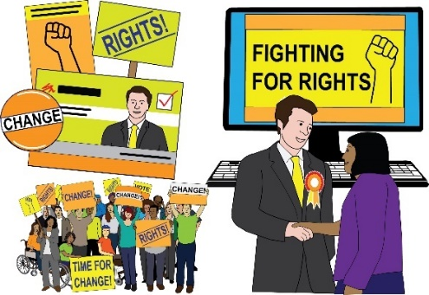 |  | - A fund for elections. This is to support adjustments for Disabled people who are running as candidates.
Candidate: here, this means a person who is running for a position in politics where the public need to vote them in.

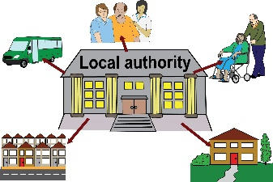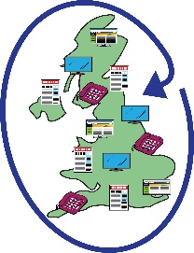 | This would be for local elections and elections that are across the country.
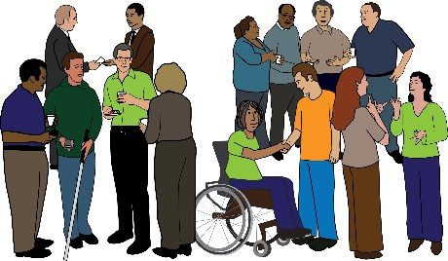 | - Funding to support the network of Disabled People’s Organisations across England.
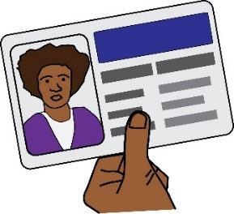 | - Taking steps to make elections accessible. One of these steps would be getting rid of voter ID.
Voter ID: this means the law that you have to show your passport, driving licence or another type of ID when you go to vote.

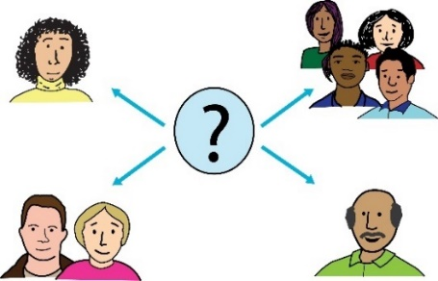  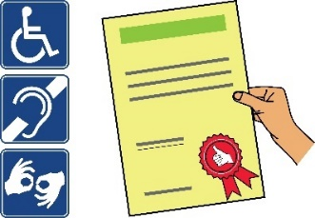 | - Taking steps to make all public consultations accessible.  There should be rules that must be followed to make sure all consultations are accessible.
Consultation: this is when people who might be affected by a change or decision are asked for information about how it will affect them.
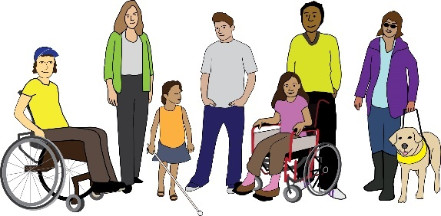 | Co-produce policies and programmes with Disabled people and our organisations. This should be at a local level and across the country.
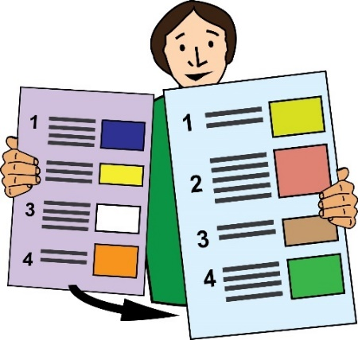 | This is the end of Part 3 of this document. Please go to Part 4 now.  In Part 4, you can read about Rights.

