Disabled People’s Manifesto

Part 5

Manifesto: here, this means our document that sets out what we want the government to do, to push for Disabled People’s rights.
 | This manifesto was written by Inclusion London
Inclusion London: we are a user-led organisation based in London. We push for equality for London’s Deaf and Disabled people.
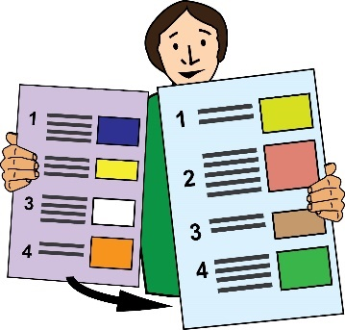 | This is Part 5 of this Manifesto. Please make sure you have read the other parts.
Four Step Plan
We have come up with a four step plan to push for change.

Step 3 – Being independent

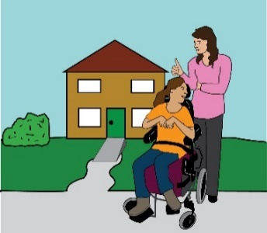 | We want the right to live in an independent way. We need choice and control over the support we get.
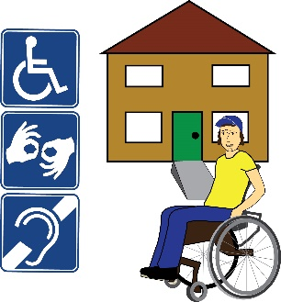 | We want the right to live in our own fully accessible homes. We should be connected to our family, friends and community.
We want big changes in society, in these areas:

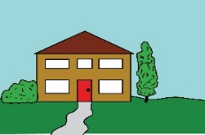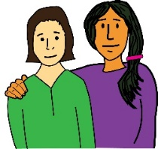 | - Social security, this means benefits support  - Social care  - Education  - Housing  - Employment
 | We want all Disabled people to have a good level of income.
Income: this means all the money coming into your account.
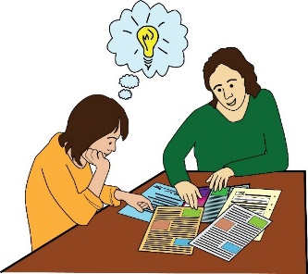  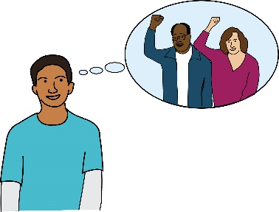 | We must have extra support that is free to use.  We want to have the support needed to enjoy our rights. We want the support needed to lead full and connected lives.
 | All disabled people should get this. It shouldn’t matter about our age, gender or background. It shouldn’t matter about our immigration status.
Immigration status: this means whether or not you have permission by law to live in the UK.
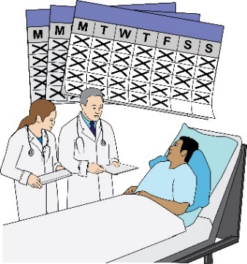 | We should not be forced to live in institutions. We should not be forced to accept medical treatment we don’t want.
Institutions: this means homes or hospitals where Disabled people live. They live away from their families and communities.
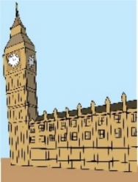 |  | This is what we are asking the government for:
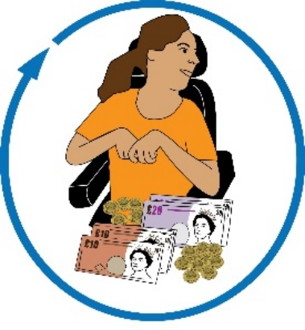 |  | Money:  - Put up the amount of disability benefits. They should meet the true extra costs of living with a disability.
 |  | - Give more money for means tested benefits. They should match the cost of living. They should match the extra costs around living with a disability.
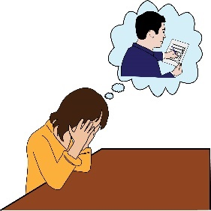 |  | - Stop giving sanctions to Disabled people.
Sanctions: this means when a person’s benefits are stopped for a period of time because they are not following the rules they agreed to at the Jobcentre.
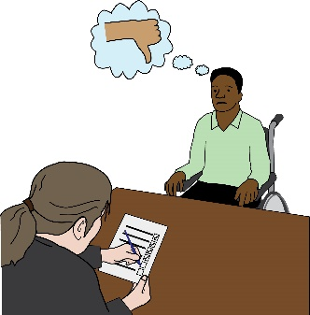  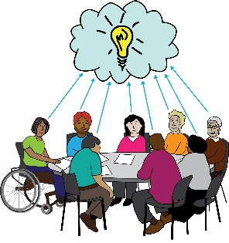  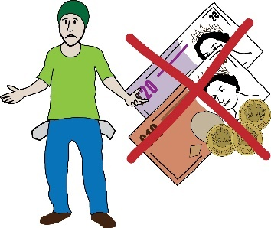 |  | - Stop cutting off Disabled people’s benefits if they couldn’t come to benefits assessments.  - Co-produce the benefits system.  The system should respect everyone’s right to a good standard of living.  - Get rid of No Recourse to Public Funds.
No recourse to public funds: this means when a person is not allowed to access benefits or healthcare because they don’t have permission to be in the UK.
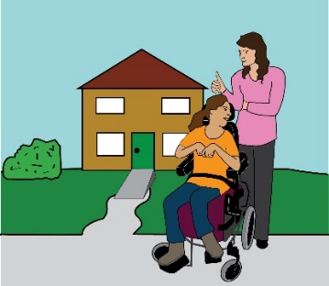 |  | Independent living:  Bring in laws for the right to independent living. Bring in a taskforce to push for independent living we can be proud of.
Independent Living: this means Disabled people living in the community with the same choices, control and freedom as anybody else.
- Put in £8 billion of extra funding for social care. Fund support that is based in the community.

- Stop charging money for social care.

 | Housing:
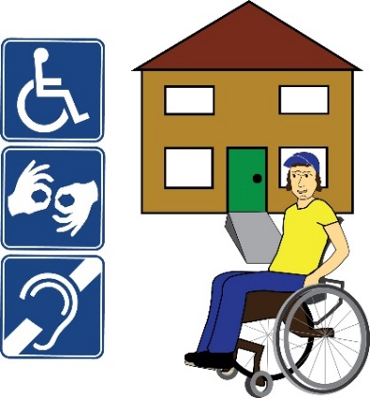 | - All new homes built must be accessible. 10% of new homes must be wheelchair accessible. Bring in this rule across the country.
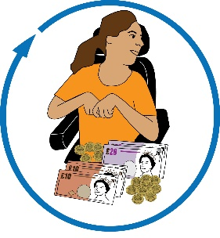 | - Put in more funding for the Disabled Facilities Grant. It shouldn’t be means tested.
Disabled Facilities Grant: this means money from the local authority to pay for housing adaptions. It aims to help disabled people stay in their own homes.

Adaptations: this means making changes to homes to make them accessible for Disabled people.
- Bring in all the suggestions from the Grenfell inquiry.

Make sure that Disabled people can leave homes safely in emergencies.

Grenfell inquiry: this was an investigation into the fire at Grenfell tower which killed 72 people in 2017.
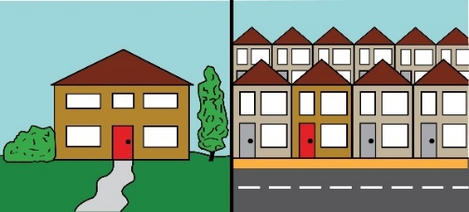 | - Bring in rules to make sure there is good quality housing. Housing should be well insulated.  There should be good housing in private and social renting sectors.
Insulate: here, this means doing work on the roof and walls of a house to stop heat from escaping. This is so people can stay warm in their homes.
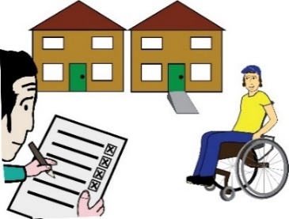 | - Making housing adaptations should be part of the Decent Homes Standard.
Decent Homes Standard: this is a set of rules that sets out the minimum standards that social housing must meet.
 | - Bring in rent caps. No one should pay more than one third of their income on rent.
Rent caps: These are a set of laws which aim to make sure that there is enough housing that people can afford to rent.
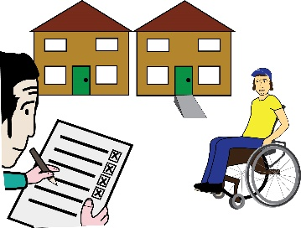 | - Put money into building social housing that is accessible.

