Disabled People’s Manifesto

Part 4

Manifesto: here, this means our document that sets out what we want the government to do, to push for Disabled People’s rights.
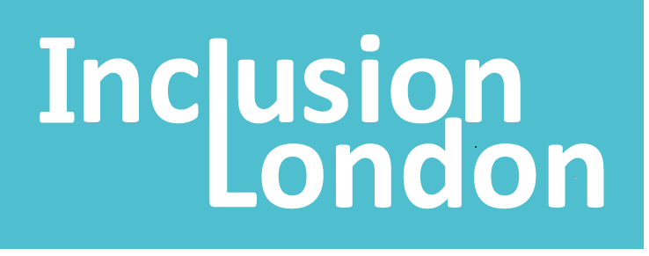 | This manifesto is by Inclusion London
Inclusion London: we are a user-led organisation based in London. We push for equality for London’s Deaf and Disabled people.
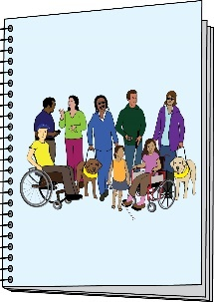  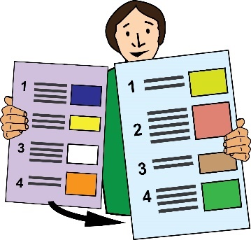 | This is Part 4 of 6 of this Manifesto.  Please make sure you go to the other parts of the Manifesto.
Four Step Plan – Step 3

Rights

We want to fully enjoy all our rights. These are promised in the UN Convention on the Rights of Persons with Disabilities.

UN Convention on the Rights of Persons with Disabilities: this is an international agreement that the government signed up to, to bring about the full rights of persons with disabilities.
We face discrimination in all areas of life. This must stop.

We want support around money and the law. This is to make sure we can enjoy our rights.

All public bodies have a responsibility by law to push for our rights and make sure they become a reality.
We want people to be held responsible when they break rules around our rights.

This is what we are asking the government for:

- Bring in laws to make the UN Convention part of UK law.

- Bring in all parts of the Equality Act. This means the socio-economic duty too.

Equality Act: this is part of the law that aims to stop people facing discrimination at work and in society.

Socio-economic Duty: This means a responsibility to think about how decisions by the government affect people who face the most barriers in society.

Duty: this means a responsibility by law.
The Equality act talks about making sure that communication is accessible.
Disability access and language access should be a part of this.
- Make the Public Sector Equality Duty better.

The Public Sector Equality Duty: this means public authorities must think about discrimination, needs and barriers. They must do this when making decisions about services and policies.
Make sure these duties and the socio-economic duties are part of decision making for all public groups.
- Make sure victims of Disability Hate Crime are treated in the same way as victims of other serious crimes.
Disability Hate Crime: this means when somebody commits a crime against a Disabled person because of their impairment.
- Bring in laws to look after Disabled people who are abused by workers and professionals.

They should have the same protection and support as victims of domestic abuse.

Domestic abuse: this means when violence happens between people in a relationship. It can be any type of bullying, controlling or violent behaviour.
Make sure that workers have proper pay and conditions to have respectful relationships.

- Bring in support to pay for costs around the law, when it comes to discrimination cases.

This support should be for everyone. It should not be means-tested.

Means-tested: this means when the amount of money you get for benefits or support is based on your income.
- End discrimination against Disabled parents. This is especially for mothers.

This discrimination could be stopped by:

- Giving social care to parents.

- Giving money to support parents.

- Giving other support to parents.

- Making family court open to the public. Making it fully accessible.

Family court: this means the court that deals with issues around the law between family members.
- Making sure that Disabled parents have a good income.

Income: this means all the money coming into your account.
- Set up an inquiry to look at deaths that are related to benefits.

Inquiry: this means setting up an investigation to find out information about something.
- Bring in laws to get rid of forced detention and treatment. This is for people with mental health needs.

Forced detention: this means when a person is forced to stay in a hospital for assessment or treatment.
This is the end of Part 4 of this document. Please go to Part 5 now.

In Part 5, you can read about Independence.

