Disabled People’s Manifesto

Part 6

Manifesto: here, this means our document that sets out what we want the government to do, to push for Disabled People’s rights.
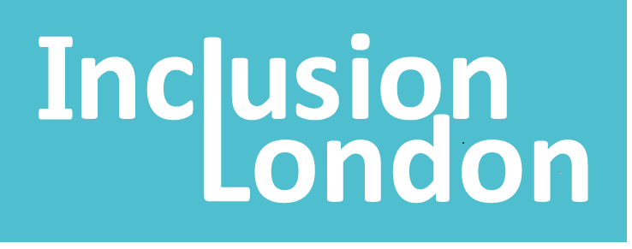 | This manifesto was written by Inclusion London
Inclusion London: we are a user-led organisation based in London. We push for equality for London’s Deaf and Disabled people.
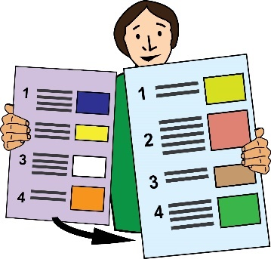 | This is Part 6 of this Manifesto. Please make sure you have read the other parts.
Four Step Plan
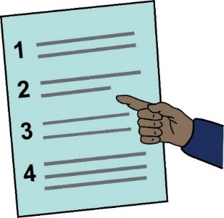 | We have come up with a four step plan to push for change.
Step 4 – Inclusion

Inclusive or inclusion: in this document, this means disabled people being able to take part in society. They must be able to take part fully, in a meaningful way.
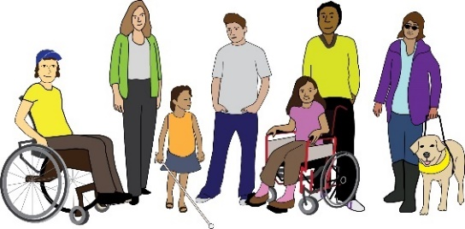  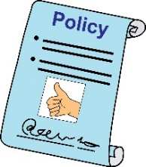  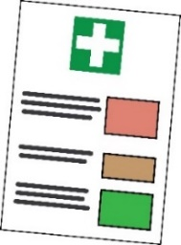  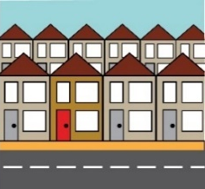  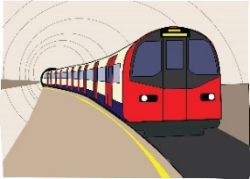  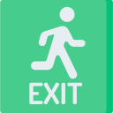 | We want plans that deal with the needs of Disabled people from the start. We want plans for all areas of life, such as:  - Energy policy  - Climate change, this means changes in weather across the world because of pollution.  - Digital work and technology  - Health  - Housing  - Transport  - Street environment  - Emergency planning
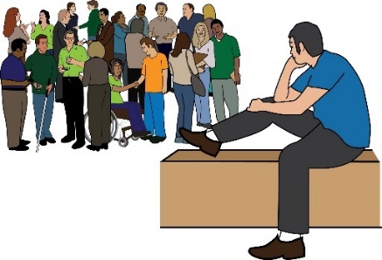 | Right now, some resources are going to segregated settings and programmes.
Resources: this means time, money, staff or anything else needed.

Segregated: this means settings or programmes where Disabled people are kept apart from the rest of society.
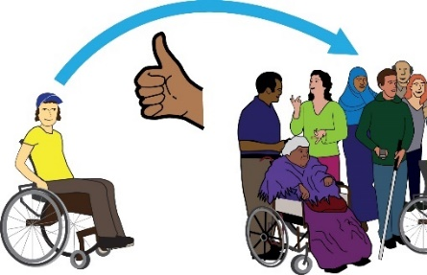 | We want these resources to be used for inclusive programmes and support instead.
What we are asking the government for:

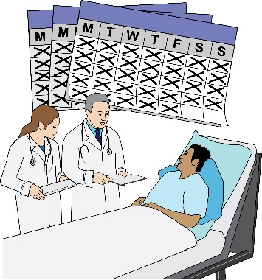 | Education:  - Work on plans with Disabled People’s Organisations to move Disabled children and adults out of all institutions.
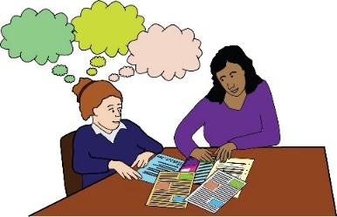 | - A right for every Disabled learner to get the right support.
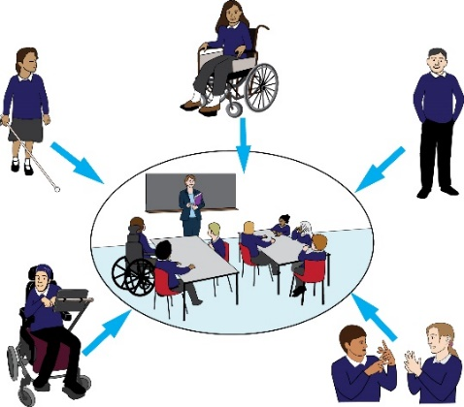 | This should be in a mainstream education setting.  This means schools where disabled people and non-disabled people learn together.
 | - Put in £3 billion extra per year for support around education.
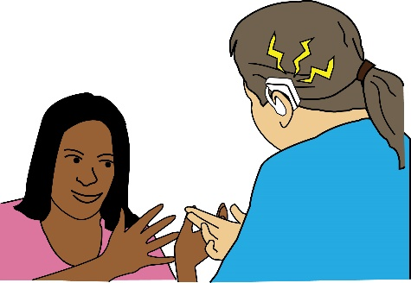 | Access:  - Make sure the British Sign Language Act is properly put into place.
British Sign Language Act: this is a law that says that sign language is an official language in the UK.
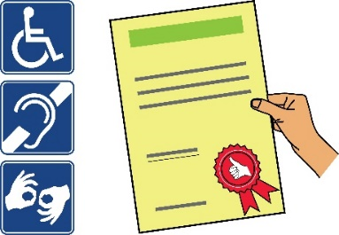  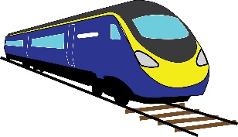  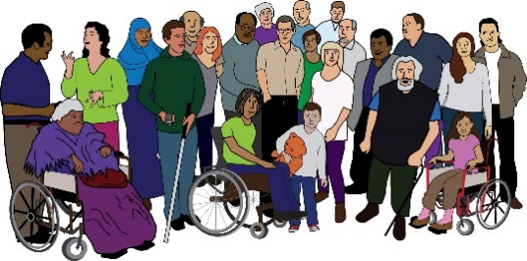 | - Bring in new standards which meet the access needs of people with different impairments.  These access rules should be in place for:  - Transport  - Built environment, this means spaces like buildings, roads and parks  - Public realm, this means places that are owned by the public.
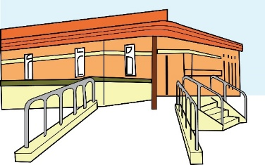  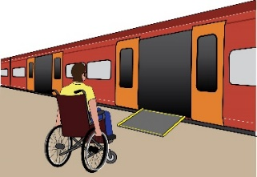  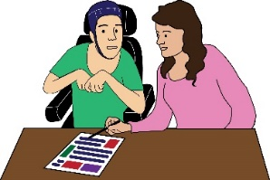 | - Bring in plans to invest in infrastructure. Bring in rules to make sure Disabled people can access:  - Environment  - Transport  - Information and communication
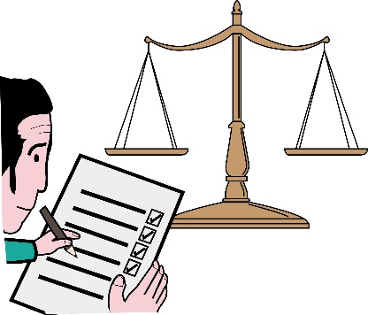 | Work:  - Bring in monitoring at work. This should be mandatory.
Monitoring: this means keeping an eye on what is going well and what needs to be done better.

Mandatory: this means when something has to be done. There is no choice whether to do it or not.
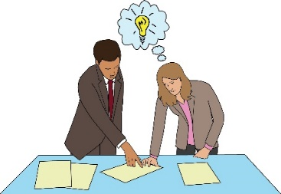 | This monitoring should look at things like pay gaps and making progress at work.
Pay gap: this means when one group of people gets paid less than another group for doing the same job.
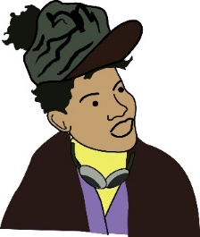 | It should especially monitor these things for Disabled women and Disabled people of colour.
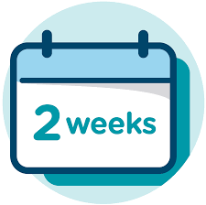  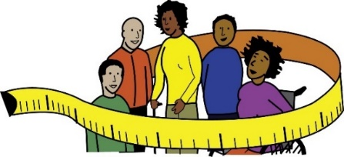 | - Bring in a two week timeframe for making adjustments. This should be mandatory.  The individual should not be responsible for sorting out their adjustments.
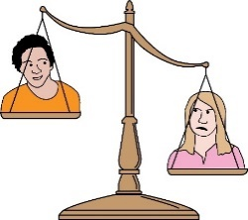 | - Make a promise to close the disability employment gap.
Disability employment gap: this means the difference between the number of Disabled people who are not working, compared to the number of non-Disabled people.
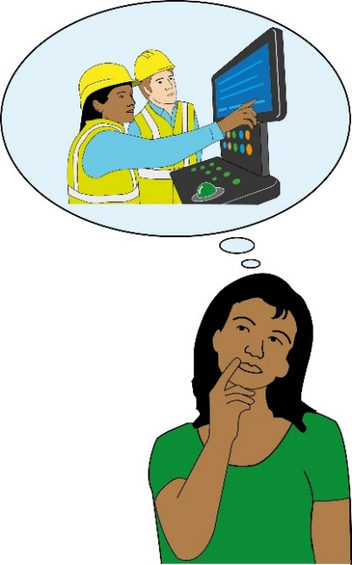 | - Bring in a right to support around employment for Disabled people.  This support should respond to the needs of people with Disabilities. This support must help Disabled people get good jobs.
 | - Make sure people can get support from Access to Work. The service must be quick and run at a good standard.
Access to Work: this is a grant to support Disabled people to find work or to stay in work.

