Disabled People’s Manifesto

Part 1

Manifesto: here, this means our document that sets out what we want the government to do, to push for Disabled People’s rights.
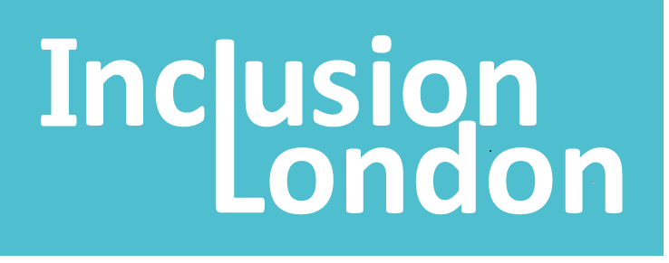 | This manifesto is by Inclusion London
Inclusion London: we are a user-led organisation based in London. We push for equality for London’s Deaf and Disabled people.
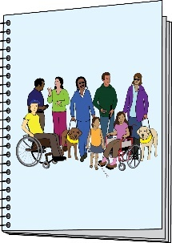  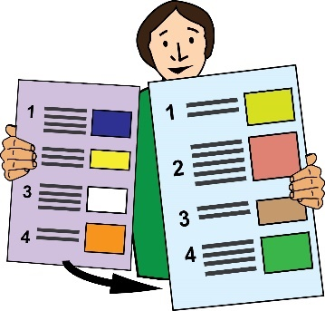 | This is Part 1 of 6 of this Manifesto.  Please make sure you go to Part 2 after you have finished reading this part.
Introduction

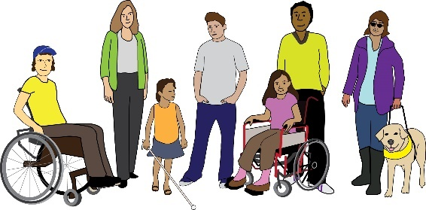 | There are 14 million Disabled people in the UK. 1 in 5 people are Disabled in the UK.
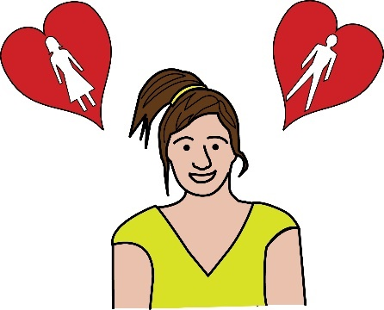  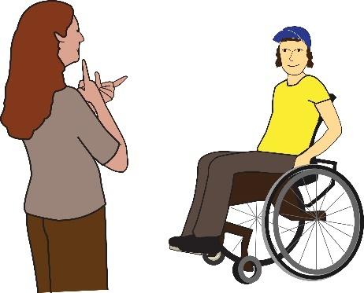 | Disabled people are not all the same. We have different:  - Genders  - Sexual orientations  - Impairments
Impairment: in this document, this is used to talk about a Disabled person’s medical condition.

Sexual orientation: this means who you feel attracted to. You might feel attracted to men, women, both or neither.
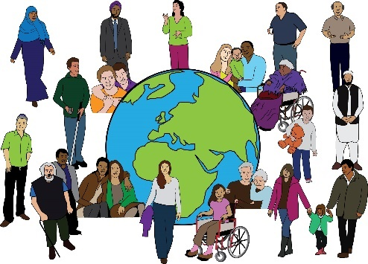 | We come from different backgrounds and we live different lives.
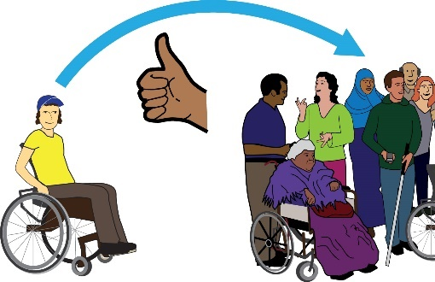 | Some of us are treated more unfairly than others. But we have lots of things in common. We all want to live in a society that is inclusive.
Inclusive or inclusion: in this document, this means disabled people being able to take part in society. They must be able to take part fully, in a meaningful way.
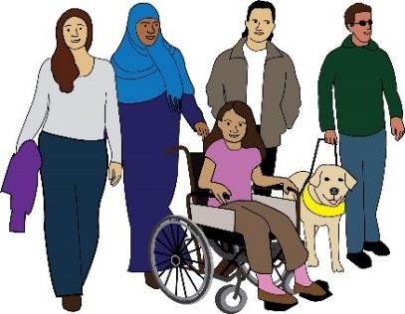 | We want to live in a society where everyone has a life that is fulfilling. We want everyone to feel connected and valued.
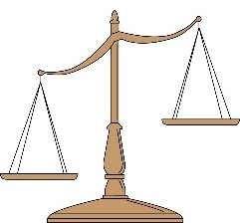 | We know our lives are not valued in an equal way, compared to others.
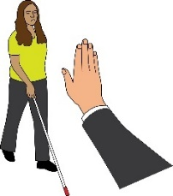 | We face discrimination and oppression in our daily lives.
Discrimination: this means being treated unfairly. This could be because of a person’s race, age, sex or because of another part of who a person is. In this document, we are talking about discrimination against Disabled people.

Oppression: this means not having power.
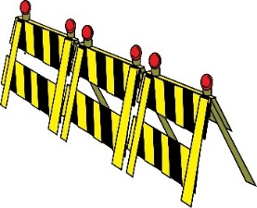 | We face barriers to our inclusion. We face barriers when it comes to taking part in society.
Barriers: in this document, this means things that stop Disabled people from living equal lives.
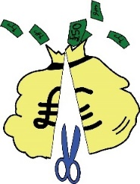 | Disabled people have been hit hardest by austerity.
Austerity: this means when the government cuts spending and raises taxes. This affects people’s standard of living in a bad way.
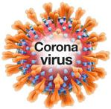 | Disabled people have also been hit hardest by the Covid pandemic.
Covid pandemic: this is the virus that has spread all over the world over the past few years. It has changed the way that people live and work. It has had lots of long-term effects on society.
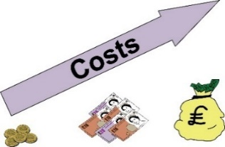 | Now, Disabled people are being hit hardest by the cost-of-living crisis.

Cost-of-living crisis: this means when the cost of basic items goes up by a lot. However, wages have not gone up. This means lots of people are struggling to afford basic needs such as food and heating.
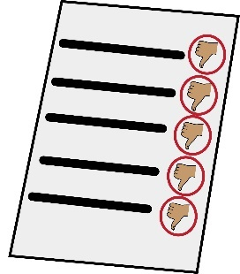  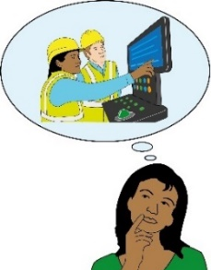  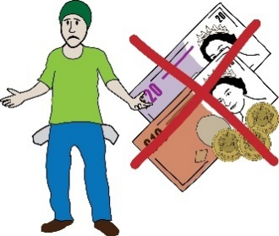 | Evidence shows that, as disabled people, we are:  - Getting worse results at school and university  - A lot more likely to be unemployed or earn less.  - Living more in poverty compared to the rest of society
Unemployment: this means when a person wants to work but they can’t find a job.

Poverty: this means not having enough money to live well or to access basic needs.
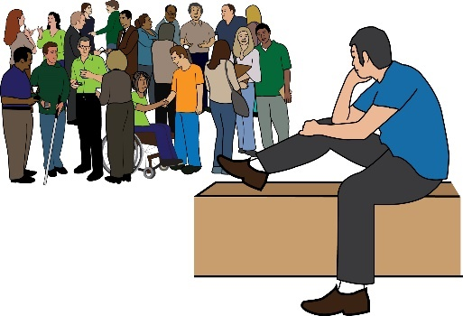 | Lots of us are forced to live away from society, our communities and families. We often have to do this if we want to access support or education.
 | Societal infrastructure is not meeting our needs.
Societal infrastructure: this means spaces and systems in society that support a good quality of life. For example, things like housing, transport and streets.
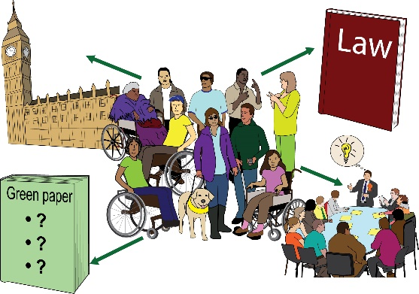 | We are asking the next UK Government to bring in a programme to make big changes in society. These changes should be radical.
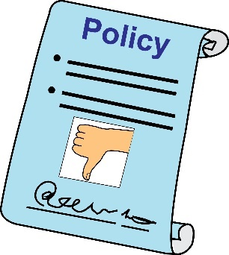 | The programme should deal with the ways policies are made. Right now, the policies are disablist.
Policies: this means rules set out by the government and other decision makers.

Disablist: this means causing discrimination against Disabled people.
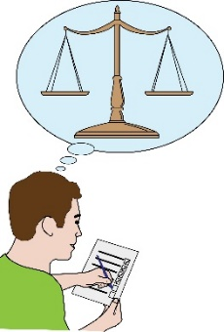 | The government must bring in changes to deal with oppression and unfairness in our systems.
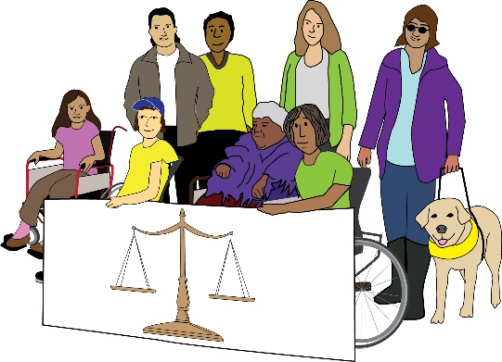 | The government must push for a society where everyone has equal life chances. Everyone must be valued and treated in an equal way.
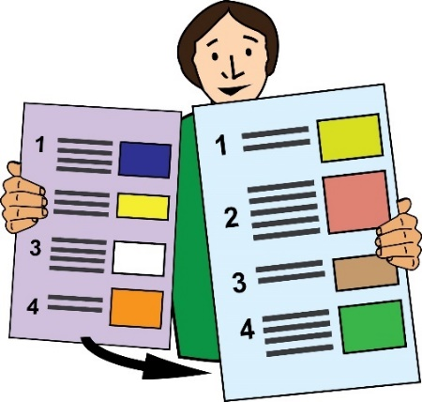 |  | This is the end of Part 1 of this document. Please go to Part 2 now.  In Part 2, you can read about Transformation.

