Disabled People’s Manifesto

Part 1

Manifesto: here, this means our document that sets out what we want the government to do, to push for Disabled People’s rights.
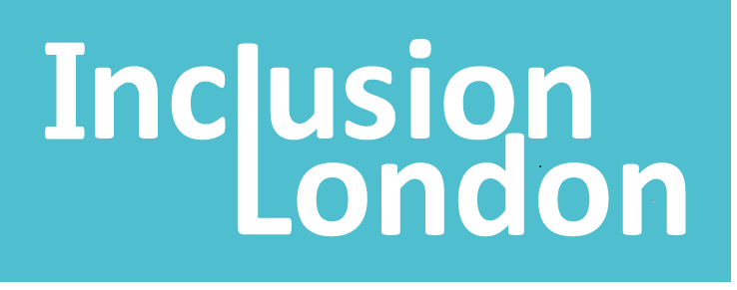 | This manifesto is by Inclusion London
Inclusion London: we are a user-led organisation based in London. We push for equality for London’s Deaf and Disabled people.
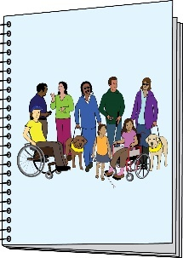  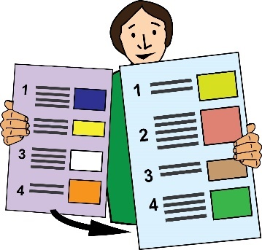 | This is Part 1 of 6 of this Manifesto.  Please make sure you go to Part 2 after you have finished reading this part.
Introduction

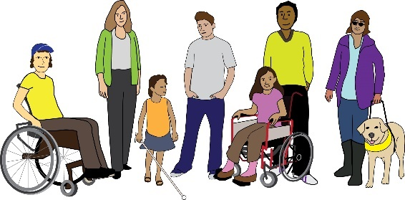 | There are 14 million Disabled people in the UK. 1 in 5 people are Disabled in the UK.
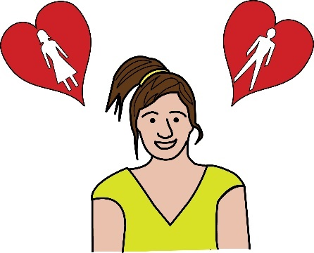  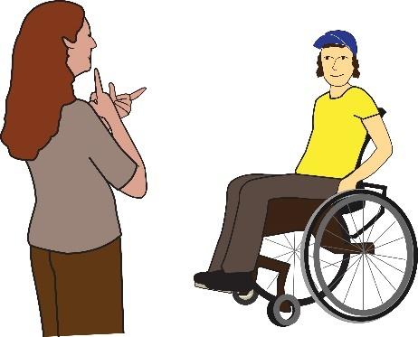 | Disabled people are not all the same. We have different:  - Genders  - Sexual orientations  - Impairments
Impairment: in this document, this is used to talk about a Disabled person’s medical condition.

Sexual orientation: this means who you feel attracted to. You might feel attracted to men, women, both or neither.
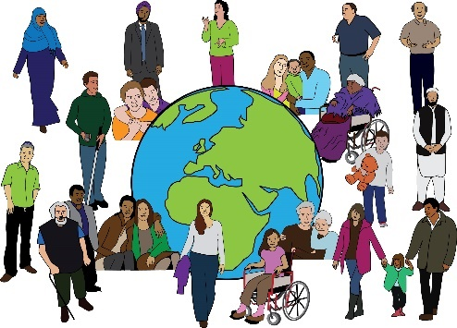 | We come from different backgrounds and we live different lives.
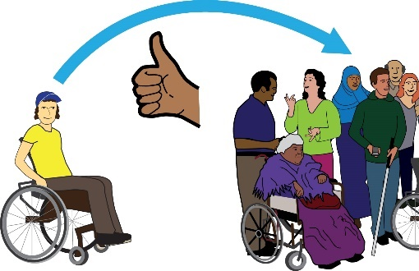 | Some of us are treated more unfairly than others. But we have lots of things in common. We all want to live in a society that is inclusive.
Inclusive or inclusion: in this document, this means disabled people being able to take part in society. They must be able to take part fully, in a meaningful way.
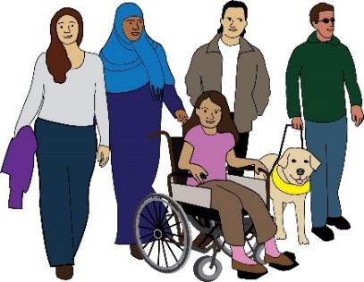 | We want to live in a society where everyone has a life that is fulfilling. We want everyone to feel connected and valued.
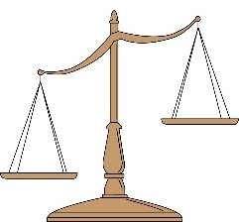 | We know our lives are not valued in an equal way, compared to others.
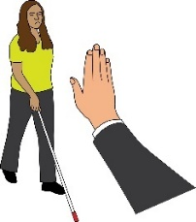 | We face discrimination and oppression in our daily lives.
Discrimination: this means being treated unfairly. This could be because of a person’s race, age, sex or because of another part of who a person is. In this document, we are talking about discrimination against Disabled people.

Oppression: this means not having power.
 | We face barriers to our inclusion. We face barriers when it comes to taking part in society.
Barriers: in this document, this means things that stop Disabled people from living equal lives.
 | Disabled people have been hit hardest by austerity.
Austerity: this means when the government cuts spending and raises taxes. This affects people’s standard of living in a bad way.
 | Disabled people have also been hit hardest by the Covid pandemic.
Covid pandemic: this is the virus that has spread all over the world over the past few years. It has changed the way that people live and work. It has had lots of long-term effects on society.
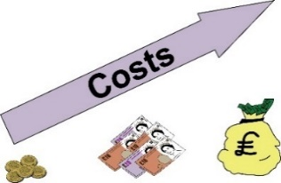 | Now, Disabled people are being hit hardest by the cost-of-living crisis.

Cost-of-living crisis: this means when the cost of basic items goes up by a lot. However, wages have not gone up. This means lots of people are struggling to afford basic needs such as food and heating.
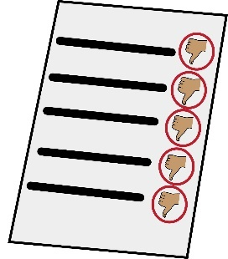  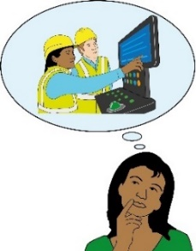  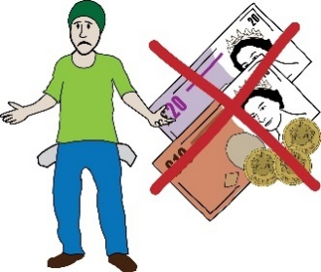 | Evidence shows that, as disabled people, we are:  - Getting worse results at school and university  - A lot more likely to be unemployed or earn less.  - Living more in poverty compared to the rest of society
Unemployment: this means when a person wants to work but they can’t find a job.

Poverty: this means not having enough money to live well or to access basic needs.
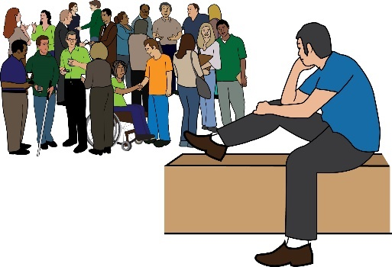 | Lots of us are forced to live away from society, our communities and families. We often have to do this if we want to access support or education.
 | Societal infrastructure is not meeting our needs.
Societal infrastructure: this means spaces and systems in society that support a good quality of life. For example, things like housing, transport and streets.
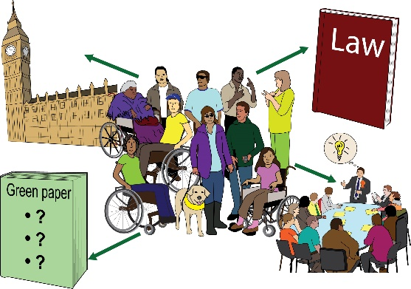 | We are asking the next UK Government to bring in a programme to make big changes in society. These changes should be radical.
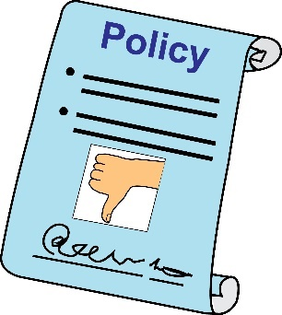 | The programme should deal with the ways policies are made. Right now, the policies are disablist.
Policies: this means rules set out by the government and other decision makers.

Disablist: this means causing discrimination against Disabled people.
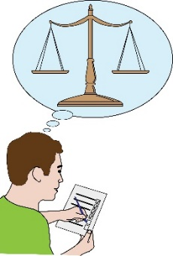 | The government must bring in changes to deal with oppression and unfairness in our systems.
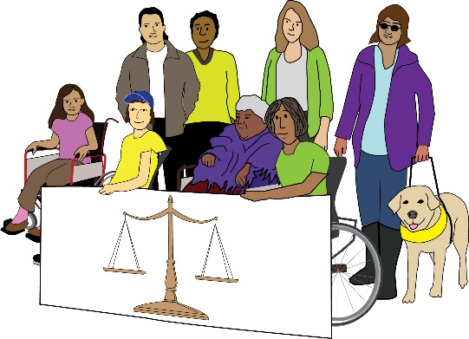 | The government must push for a society where everyone has equal life chances. Everyone must be valued and treated in an equal way.
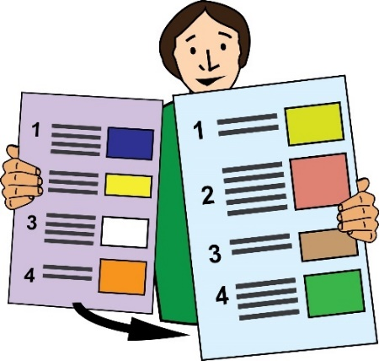 |  | This is the end of Part 1 of this document. Please go to Part 2 now.  In Part 2, you can read about Transformation.

Disabled People’s Manifesto

Part 2

Manifesto: here, this means our document that sets out what we want the government to do, to push for Disabled People’s rights.
 | This manifesto is by Inclusion London
Inclusion London: we are a user-led organisation based in London. We push for equality for London’s Deaf and Disabled people.
This is Part 2 of 6 of this Manifesto.

Please make sure you read the other parts of the Manifesto.

Transformation: this means pushing for big changes

 | We want the government to accept that getting rid of barriers will cost lots of money. To get rid of barriers, austerity must end.
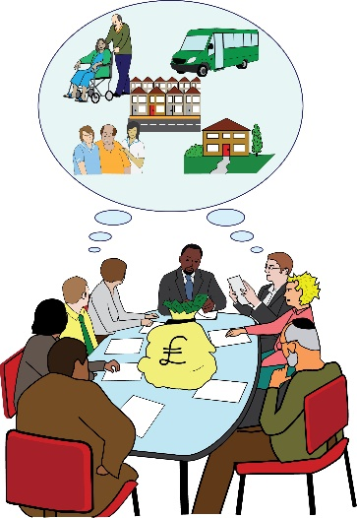 | Putting money into good public services is not a waste of money. It is not wasting the budget.  In fact, it is an investment in everyone’s quality of life.
Budget: here, this means the government’s plan about the money they have and how they will spend it.

Invest or investment: this means using time, money and other resources to make long-term change.
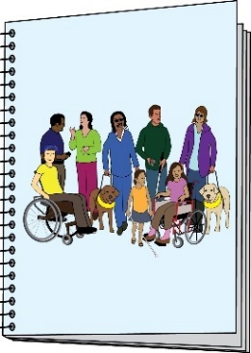 | We need a long-term Disability Strategy. This should be co-produced with Disabled people and our organisations.
Strategy: this means a long-term plan.

Co-produce or co-production: here, this means the government working together with Disabled people.
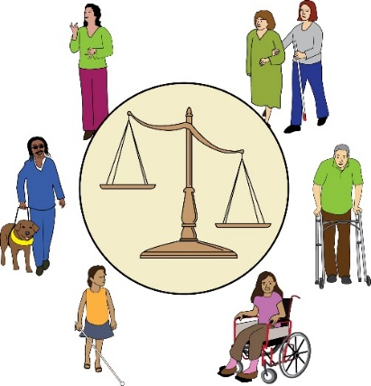 | This strategy should deal with the structures in society that are causing our oppression. The strategy should lead to change and investment.
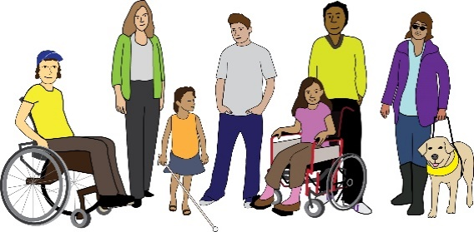 | This is so that Disabled people can have really good lives.  This means Disabled people of all ages, genders and backgrounds.

Disabled People’s Manifesto

Part 3

Manifesto: here, this means our document that sets out what we want the government to do, to push for Disabled People’s rights.
 | This manifesto is by Inclusion London
Inclusion London: we are a user-led organisation based in London. We push for equality for London’s Deaf and Disabled people.
This is Part 3 of 6 of this Manifesto.

Please make sure you go to the other parts of the Manifesto.
.

Four Step Plan – Step 1

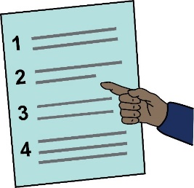 | Representing Disabled people and having a voice
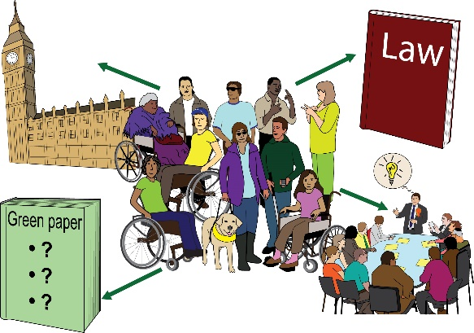  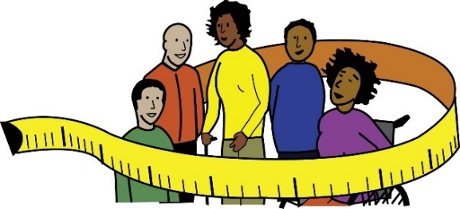 | We want Disabled people to take part across all political and public roles.  We need adjustments to be put in place. We need this to happen for all the adjustments that are needed.  This is so we can reach real justice and equality.
Adjustments: here, this means making changes to get rid of barriers for Disabled people.
Disabled People’s Organisations are responsible for our community.

These organisations must be seen as the most important advocates for us.

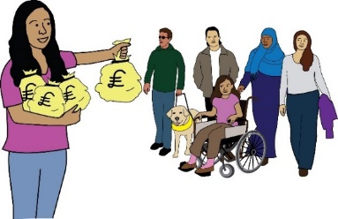 |  | They must be given the funding needed to carry out their important work.
Advocate: here, this means people and groups who stand up for and talk about Disabled people’s rights
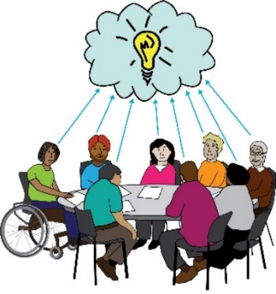  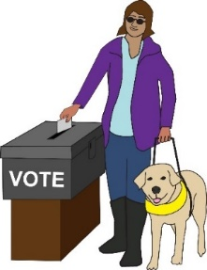 |  | Disabled People’s Organisations must take part in making decisions. This must be in local settings and across the UK.  All Disabled people must be able to fully take part in voting.
This is what we are asking the government for:
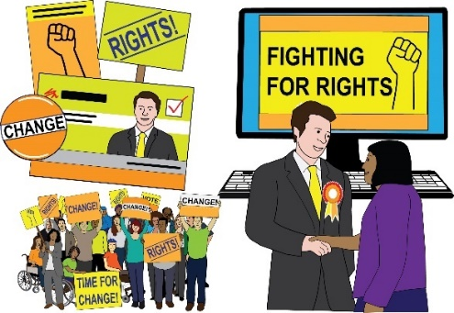 |  | - A fund for elections. This is to support adjustments for Disabled people who are running as candidates.
Candidate: here, this means a person who is running for a position in politics where the public need to vote them in.

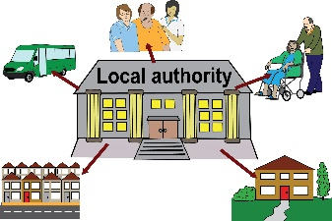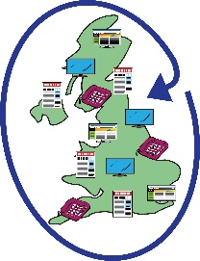 | This would be for local elections and elections that are across the country.
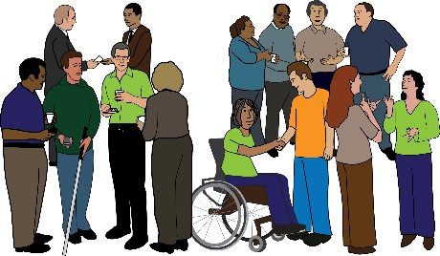 | - Funding to support the network of Disabled People’s Organisations across England.
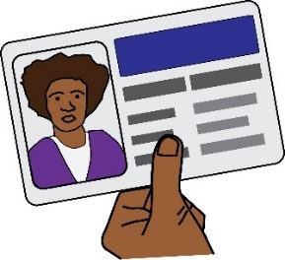 | - Taking steps to make elections accessible. One of these steps would be getting rid of voter ID.
Voter ID: this means the law that you have to show your passport, driving licence or another type of ID when you go to vote.

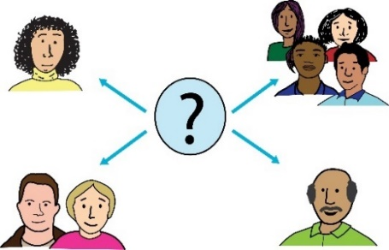  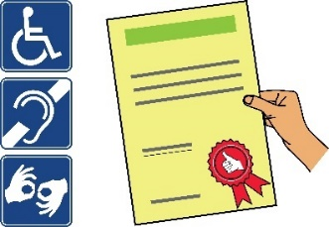 | - Taking steps to make all public consultations accessible.  There should be rules that must be followed to make sure all consultations are accessible.
Consultation: this is when people who might be affected by a change or decision are asked for information about how it will affect them.
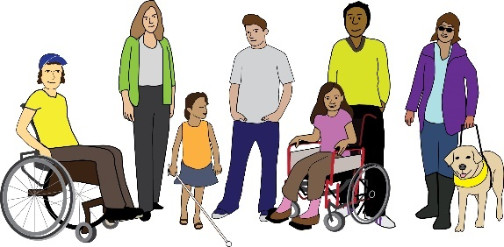 | Co-produce policies and programmes with Disabled people and our organisations. This should be at a local level and across the country.
This is the end of Part 3 of this document. Please go to Part 4 now.

In Part 4, you can read about Rights.

Disabled People’s Manifesto

Part 4

Manifesto: here, this means our document that sets out what we want the government to do, to push for Disabled People’s rights.
This manifesto is by Inclusion London

Inclusion London: we are a user-led organisation based in London. We push for equality for London’s Deaf and Disabled people.
This is Part 4 of 6 of this Manifesto.

Please make sure you go to the other parts of the Manifesto.

Four Step Plan – Step 2

Rights

We want to fully enjoy all our rights. These are promised in the UN Convention on the Rights of Persons with Disabilities.

UN Convention on the Rights of Persons with Disabilities: this is an international agreement that the government signed up to, to bring about the full rights of persons with disabilities.
We face discrimination in all areas of life. This must stop.

We want support around money and the law. This is to make sure we can enjoy our rights.

All public bodies have a responsibility by law to push for our rights and make sure they become a reality.
We want people to be held responsible when they break rules around our rights.

This is what we are asking the government for:

- Bring in laws to make the UN Convention part of UK law.

- Bring in all parts of the Equality Act. This means the socio-economic duty too.

Equality Act: this is part of the law that aims to stop people facing discrimination at work and in society.

Socio-economic Duty: This means a responsibility to think about how decisions by the government affect people who face the most barriers in society.

Duty: this means a responsibility by law.
The Equality act talks about making sure that communication is accessible.
Disability access and language access should be a part of this.
 | - Make the Public Sector Equality Duty better.
The Public Sector Equality Duty: this means public authorities must think about discrimination, needs and barriers. They must do this when making decisions about services and policies.
 | Make sure these duties and the socio-economic duties are part of decision making for all public groups.
 | - Make sure victims of Disability Hate Crime are treated in the same way as victims of other serious crimes.
Disability Hate Crime: this means when somebody commits a crime against a Disabled person because of their impairment.
- Bring in laws to look after Disabled people who are abused by workers and professionals.

They should have the same protection and support as victims of domestic abuse.

Domestic abuse: this means when violence happens between people in a relationship. It can be any type of bullying, controlling or violent behaviour.
 | Make sure that workers have proper pay and conditions to have respectful relationships.
- Bring in support to pay for costs around the law, when it comes to discrimination cases.

This support should be for everyone. It should not be means-tested.

Means-tested: this means when the amount of money you get for benefits or support is based on your income.
 |  | - End discrimination against Disabled parents. This is especially for mothers.
This discrimination could be stopped by:

- Giving social care to parents.

- Giving money to support parents.

- Giving other support to parents.

- Making family court open to the public. Making it fully accessible.

Family court: this means the court that deals with issues around the law between family members.
 | - Making sure that Disabled parents have a good income.
Income: this means all the money coming into your account.
 | - Set up an inquiry to look at deaths that are related to benefits.
Inquiry: this means setting up an investigation to find out information about something.
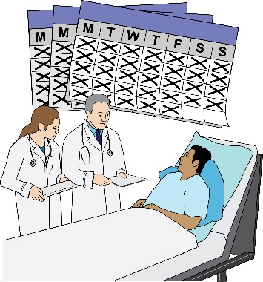 | - Bring in laws to get rid of forced detention and treatment. This is for people with mental health needs.
Forced detention: this means when a person is forced to stay in a hospital for assessment or treatment.
This is the end of Part 4 of this document. Please go to Part 5 now.

In Part 5, you can read about Independence.

Disabled People’s Manifesto

Part 5

Manifesto: here, this means our document that sets out what we want the government to do, to push for Disabled People’s rights.
 | This manifesto was written by Inclusion London
Inclusion London: we are a user-led organisation based in London. We push for equality for London’s Deaf and Disabled people.
 | This is Part 5 of this Manifesto. Please make sure you have read the other parts.
Four Step Plan
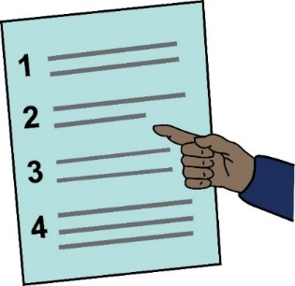 | We have come up with a four step plan to push for change.

Step 3 – Being independent

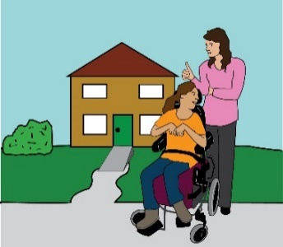 | We want the right to live in an independent way. We need choice and control over the support we get.
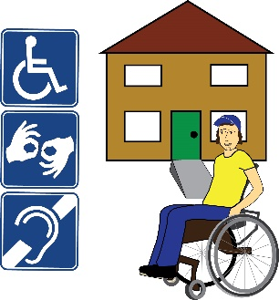 | We want the right to live in our own fully accessible homes. We should be connected to our family, friends and community.
We want big changes in society, in these areas:

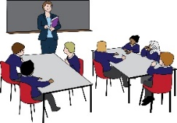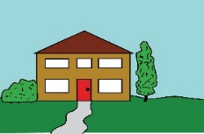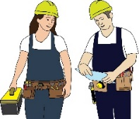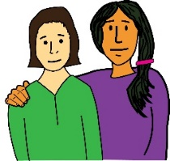 | - Social security, this means benefits support  - Social care  - Education  - Housing  - Employment
 | We want all Disabled people to have a good level of income.
Income: this means all the money coming into your account.
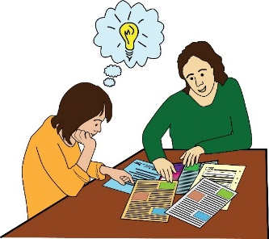  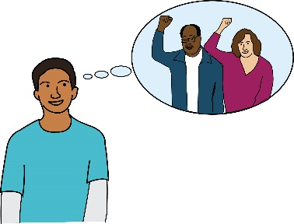 | We must have extra support that is free to use.  We want to have the support needed to enjoy our rights. We want the support needed to lead full and connected lives.
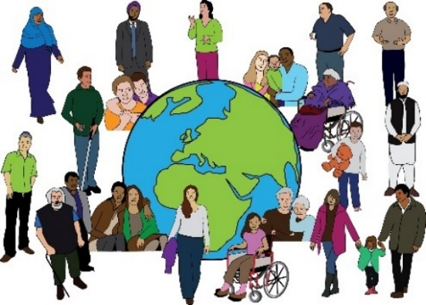 | All disabled people should get this. It shouldn’t matter about our age, gender or background. It shouldn’t matter about our immigration status.
Immigration status: this means whether or not you have permission by law to live in the UK.
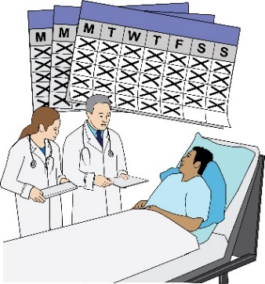 | We should not be forced to live in institutions. We should not be forced to accept medical treatment we don’t want.
Institutions: this means homes or hospitals where Disabled people live. They live away from their families and communities.
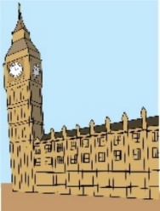 |  | This is what we are asking the government for:
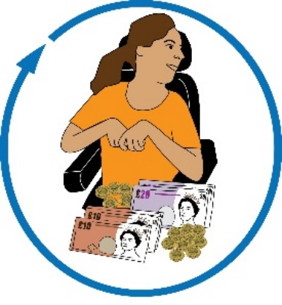 |  | Money:  - Put up the amount of disability benefits. They should meet the true extra costs of living with a disability.
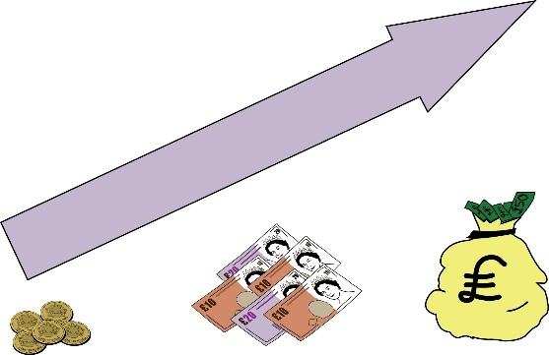 |  | - Give more money for means tested benefits. They should match the cost of living. They should match the extra costs around living with a disability.
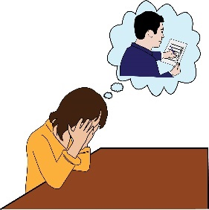 |  | - Stop giving sanctions to Disabled people.
Sanctions: this means when a person’s benefits are stopped for a period of time because they are not following the rules they agreed to at the Jobcentre.
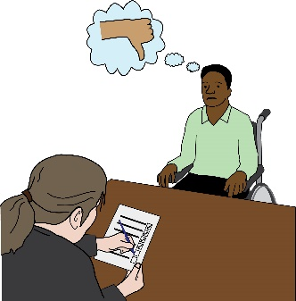  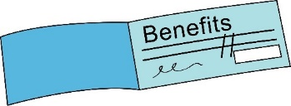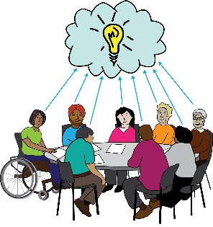  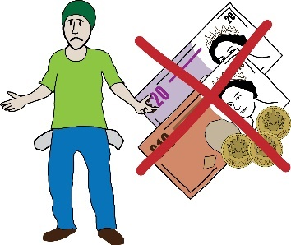 |  | - Stop cutting off Disabled people’s benefits if they couldn’t come to benefits assessments.  - Co-produce the benefits system.  The system should respect everyone’s right to a good standard of living.  - Get rid of No Recourse to Public Funds.
No recourse to public funds: this means when a person is not allowed to access benefits or healthcare because they don’t have permission to be in the UK.
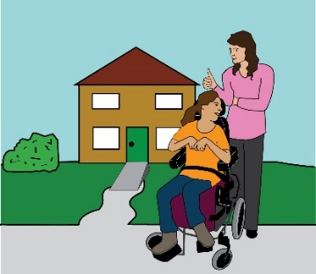 |  | Independent living:  Bring in laws for the right to independent living. Bring in a taskforce to push for independent living we can be proud of.
Independent Living: this means Disabled people living in the community with the same choices, control and freedom as anybody else.
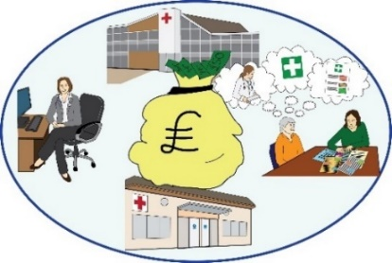 |  | - Put in £8 billion of extra funding for social care. Fund support that is based in the community.  - Stop charging money for social care.

 | Housing:
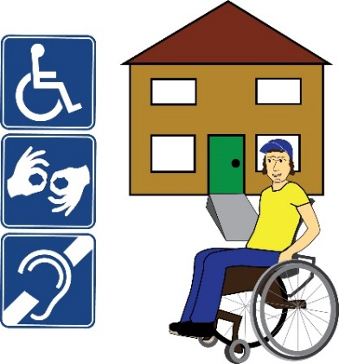 | - All new homes built must be accessible. 10% of new homes must be wheelchair accessible. Bring in this rule across the country.
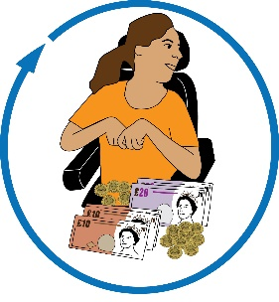 | - Put in more funding for the Disabled Facilities Grant. It shouldn’t be means tested.
Disabled Facilities Grant: this means money from the local authority to pay for housing adaptions. It aims to help disabled people stay in their own homes.

Adaptations: this means making changes to homes to make them accessible for Disabled people.
- Bring in all the suggestions from the Grenfell inquiry.

Make sure that Disabled people can leave homes safely in emergencies.

Grenfell inquiry: this was an investigation into the fire at Grenfell tower which killed 72 people in 2017.
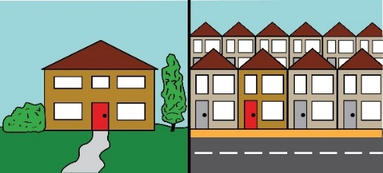 | - Bring in rules to make sure there is good quality housing. Housing should be well insulated.  There should be good housing in private and social renting sectors.
Insulate: here, this means doing work on the roof and walls of a house to stop heat from escaping. This is so people can stay warm in their homes.
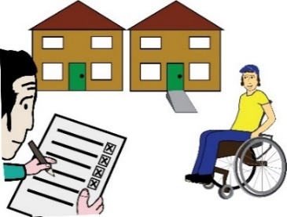 | - Making housing adaptations should be part of the Decent Homes Standard.
Decent Homes Standard: this is a set of rules that sets out the minimum standards that social housing must meet.
 | - Bring in rent caps. No one should pay more than one third of their income on rent.
Rent caps: These are a set of laws which aim to make sure that there is enough housing that people can afford to rent.
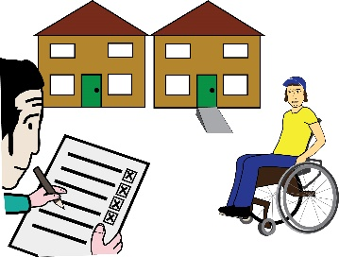 | - Put money into building social housing that is accessible.

Disabled People’s Manifesto

Part 6

Manifesto: here, this means our document that sets out what we want the government to do, to push for Disabled People’s rights.
 | This manifesto was written by Inclusion London
Inclusion London: we are a user-led organisation based in London. We push for equality for London’s Deaf and Disabled people.
 | This is Part 6 of this Manifesto. Please make sure you have read the other parts.
Four Step Plan
 | We have come up with a four step plan to push for change.
Step 4 – Inclusion

Inclusive or inclusion: in this document, this means disabled people being able to take part in society. They must be able to take part fully, in a meaningful way.
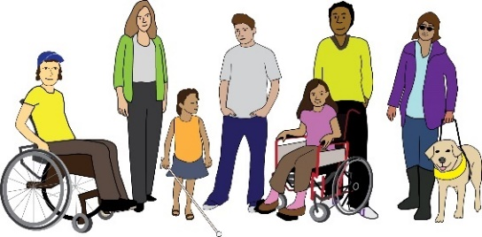  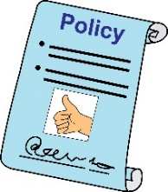  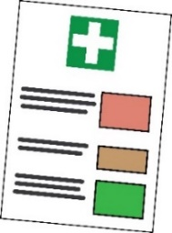  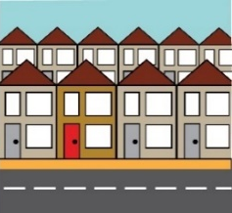  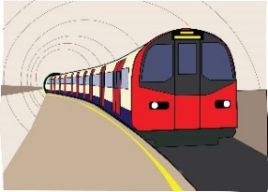 | We want plans that deal with the needs of Disabled people from the start. We want plans for all areas of life, such as:  - Energy policy  - Climate change, this means changes in weather across the world because of pollution.  - Digital work and technology  - Health  - Housing  - Transport  - Street environment  - Emergency planning
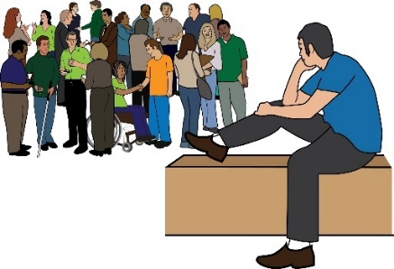 | Right now, some resources are going to segregated settings and programmes.
Resources: this means time, money, staff or anything else needed.

Segregated: this means settings or programmes where Disabled people are kept apart from the rest of society.
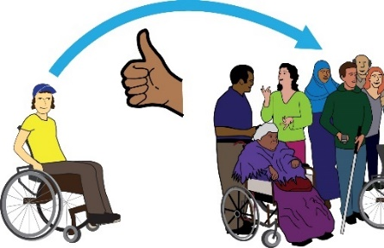 | We want these resources to be used for inclusive programmes and support instead.
What we are asking the government for:

Education:

- Work on plans with Disabled People’s Organisations to move Disabled children and adults out of all institutions.

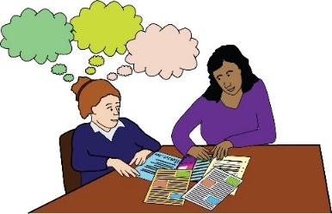 | - A right for every Disabled learner to get the right support.
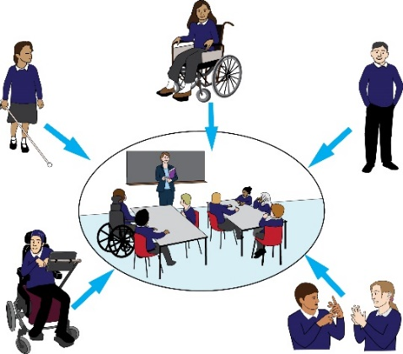 | This should be in a mainstream education setting.  This means schools where disabled people and non-disabled people learn together.
 | - Put in £3 billion extra per year for support around education.
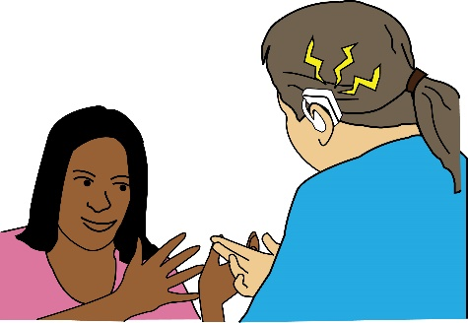 | Access:  - Make sure the British Sign Language Act is properly put into place.
British Sign Language Act: this is a law that says that sign language is an official language in the UK.
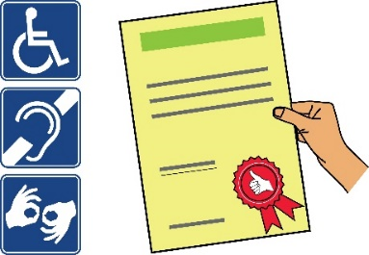  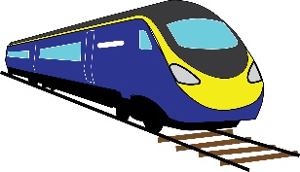  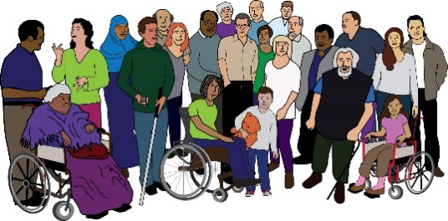 | - Bring in new standards which meet the access needs of people with different impairments.  These access rules should be in place for:  - Transport  - Built environment, this means spaces like buildings, roads and parks  - Public realm, this means places that are owned by the public.
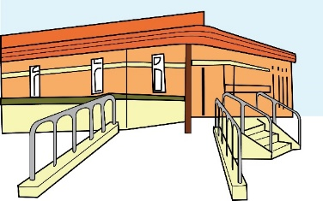  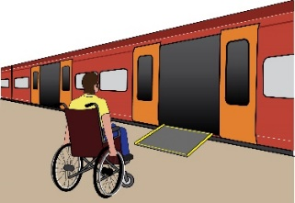  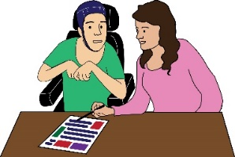 | - Bring in plans to invest in infrastructure. Bring in rules to make sure Disabled people can access:  - Environment  - Transport  - Information and communication
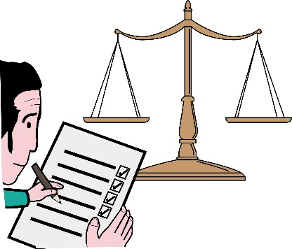 | Work:  - Bring in monitoring at work. This should be mandatory.
Monitoring: this means keeping an eye on what is going well and what needs to be done better.

Mandatory: this means when something has to be done. There is no choice whether to do it or not.
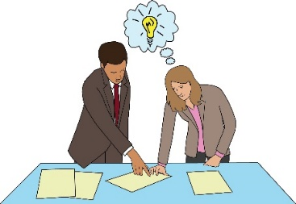 | This monitoring should look at things like pay gaps and making progress at work.
Pay gap: this means when one group of people gets paid less than another group for doing the same job.
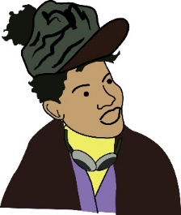 | It should especially monitor these things for Disabled women and Disabled people of colour.
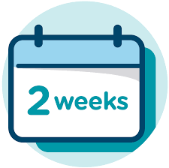  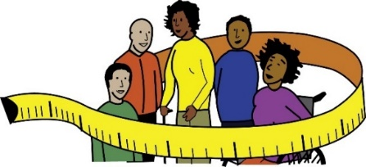 | - Bring in a two week timeframe for making adjustments. This should be mandatory.  The individual should not be responsible for sorting out their adjustments.
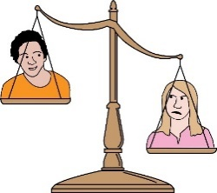 | - Make a promise to close the disability employment gap.
Disability employment gap: this means the difference between the number of Disabled people who are not working, compared to the number of non-Disabled people.
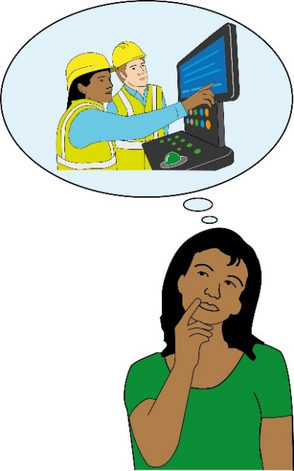 | - Bring in a right to support around employment for Disabled people.  This support should respond to the needs of people with Disabilities. This support must help Disabled people get good jobs.
 | - Make sure people can get support from Access to Work. The service must be quick and run at a good standard.
Access to Work: this is a grant to support Disabled people to find work or to stay in work.

